INDHUMATHI J  AI Java Full Stack Developer  📍 Sivakasi, Tamil Nadu | 📞 +91 7010907575 |  ✉️ indhu266003@gmail.com  🔗 GitHub: indhujanakar266003/indhu |  🔗 LinkedIn: https://www.linkedin.com/in/indhu-mathi-a57b652b4/ | | 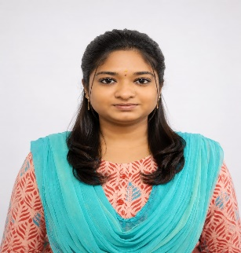

PROFESSIONAL SUMMARY
Postgraduate in Commerce with Computer Applications and currently enhancing technical expertise through AI Java Full Stack Development training. Skilled in HTML, CSS, Bootstrap, JavaScript, Microsoft Office, and Tally. Strong interest in learning new technologies and contributing effectively in a professional environment through analytical and problem-solving abilities.
TECHNICAL SKILLS
Category | Skills
Frontend | HTML5, CSS3, JavaScript, Bootstrap, Responsive Web Design
Database | MySQL, Database Fundamentals
Tools | VS Code, GitHub, Git, MS Excel
AI Tools | ChatGPT, Claude, Gemini, GitHub Copilot, DeepSeek, Qodo
Core Skills | Problem Solving, Analytical Thinking, Communication, Team Collaboration

INTERNSHIP EXPERIENCE
The Vignesh Printograph – Intern
Duration: 15 Days
Key Responsibilities:
• Worked with Tally for basic accounting and record maintenance
• Supported designing activities and assisted in creative work execution
• Performed data entry and maintained documentation accuracy
• Improved communication, time management, and workplace coordination skills

PROJECTS
Toy Shop Website project.
Designed and developed a responsive toy shop website using HTML and CSS.
Crackers Website project.
Designed and developed a responsive crackers shopping website using HTML, CSS, and Bootstrap.
TRAINING
- AI Java Full Stack Development Training — We Grow (2026)

EDUCATION
Degree | Institution | Status
M.Com - Computer Application | S. F. R. College for women, Sivakasi | Completed
B.Com - Computer Application | S. F. R. College for women, Sivakasi | Completed

CERTIFICATIONS
- AI Java Full Stack Development Training – We Grow Skill Campus, Sivakasi
- Service Marketing – S. F. R. College for women, Sivakasi

ADDITIONAL INFORMATION
- Passionate about AI and Full Stack Development
- Willing to learn and adapt to emerging technologies
- Good time management and organizational skills
- Positive attitude and continuous learning mindset

